Character attributes

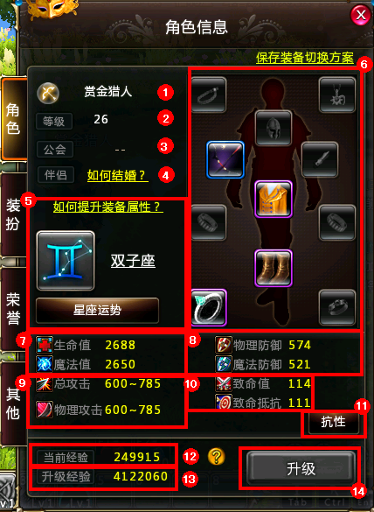

1 Name - displays the player's role in the game played by the name

2, level - the role of the current level

3 , the Association - Display current role resides Association

4 , Couples - Displays the current role of partner

5 , Constellation - Constellation can select horoscope divination performed StarSignMatch , access constellation mission

6 , the value of life - the role of the current value of life, the life time value of 0 indicates that your death

Mana - the role of the current mana , release skills needed to consume mana , lack of mana , you will not be able to release technology

7 , physical defense , magic defense - two defensive players of the value , the lower the value the greater the damage defense

8 , physical attacks, magic attacks - the value of the player's two attacks , attacks on people or blame the higher the value the greater the damage

9 Deadly value - players the chance of a critical strike

Fatal resist - players suffer a fatal blow to the chances of the size of the damage

10 , the resistance - resistance to display all the players can be divided into four categories: category element , ignoring class , state strengthening class , state arrived

11 , the current experience - experience of players currently owned

12 , upgrade experience - Experience total current up to the next set of players needed

13 upgrade - Experience reached when the upgrade experience can click the button to upgrade